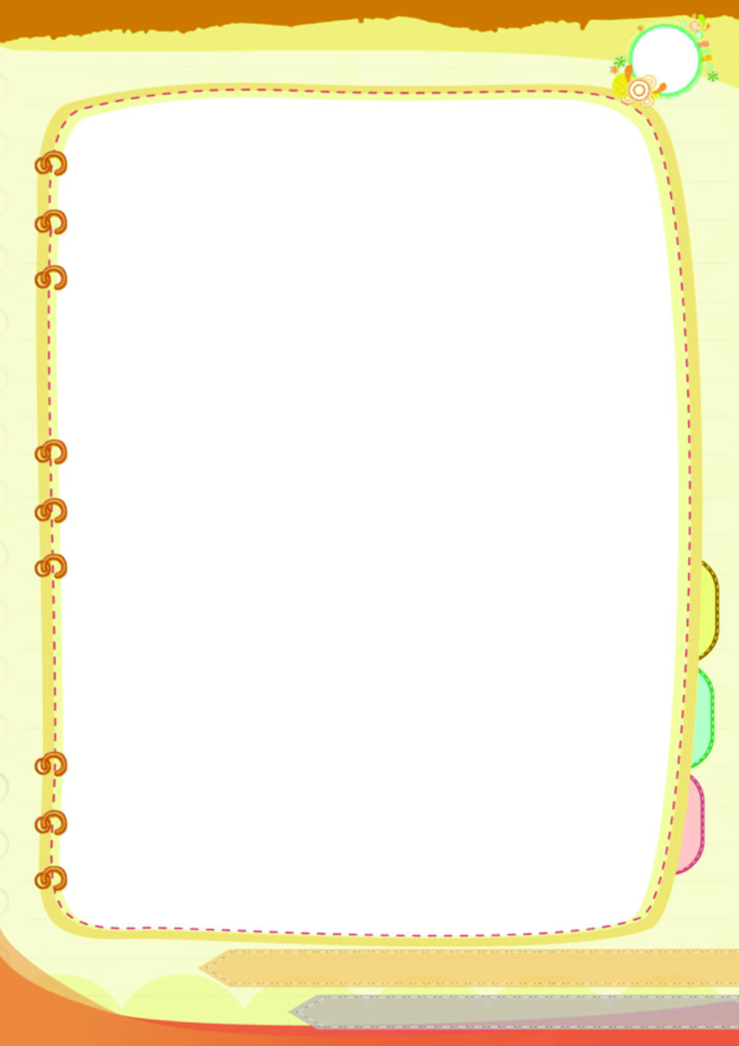
ใบงาน
ชื่อ-สกุล.....................................................................................เลขที่..............ชั้น............
คอมพิวเตอร์ในชีวิตประจำวัน
คำชี้แจง ให้นักเรียนเขียนว่าในปัจจุบันคอมพิวเตอร์มีความสำคัญอย่างไร และบอกประโยชน์ของคอมพิวเตอร์

..........................................................................................................................................................................................................................................................................................................................................................................................................................................................................................................................................................................................................................................................................................................................................................................................................................................................................................................................................................................................................................................................................................................................................................................................................................................................................................................................................................................................................................................................................................................................................................................................................................................................................................................................................................................................................................................................................................................................................................................................................................................................................................................................................................................................................................................................................................................................................................................................................................................................................................................................................................................................................................................................................................................................................................................................................................................................................................................................................................................................................................................................................................................................................................................................................................................................................................................................................................................................................................................................................................................................................................................................................................................................................................................................................................................................................................................................................................................................................................................................................................................................................................................................................................................................................................................................................................................................................................................................................................................................................................................................................................................................................................................................................................................................................................................................................................................................................................
.............................................................................................................................................................................


